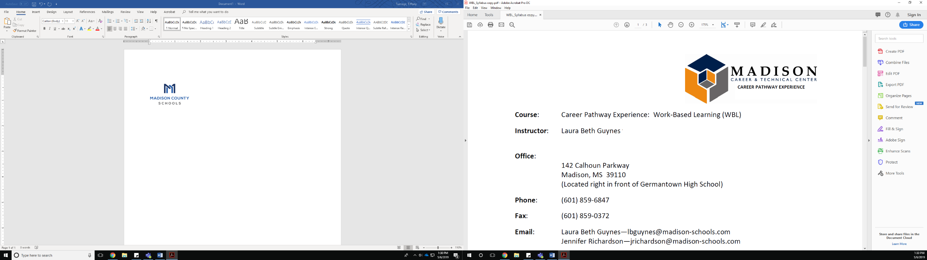

**Course:** Work-Based Learning (WBL)   
**Instructors:**  Laura Beth Guynes and Stephen Steed

**Contact Information:**

**Phone:**  (601) 859-6847

**Email:**  [lbguynes@madison-schools.com](mailto:lbguynes@madison-schools.com)  
**Email:**  [ste100@madison-schools.com](mailto:ste100@madison-schools.com)

**Course Description:**

Work Based Learning is an elective class that allows for students to earn high school credit with a combination of job site training and school work in a distance learning setting for college and career readiness. Your student is eligble for up to 2 credits upon the successful completion of the course. This course is designed to foster self-directed learning, strengthen the development of core academic skills through application in authentic situations, allow students to explore career option,; enhance communication skills, leadership, and problem solving, and contribute to community economic development.

At the WBL site, employers participate by setting standards for the student to follow and by evaluating student job performance. The instructor will monitor progress through the course timeline. Students should utilize their early dismissal/late arrival to complete their coursework, projects, and work site requirements.

**Course Objectives:**

The purpose of WBL is to help students develop skills and attitudes that will help them be successful at school and work. Skills are developed, including and not limited to:

* Ability to listen to directions and follow through
* Attention to detail
* Initiative
* Self-awareness (i.e. self-evaluation)
* Planning skills (i.e. career path)
* Communication skills, including conflict resolution skills (i.e. customer service skills)
* Technology and research skills (i.e. use of internet to find a job, use of word processing software to prepare a resume)
* Basic mathematical skills (i.e. how to calculate their average hours worked, how to calculate their class grade)

**Course assignments and requirements:**

The student must be employed in an occupation that is related to the career they plan to pursue. Assignments will be similar to an online course to produce evidence of work and they will relate using our required communication of MCS email, TEAMs, and Canvas. Students will receive grades for their communication, documentation, and interpersonal skills.

Students must submit the following forms upon request:

* Application
* Recommendations
* Rules/Regulations
* Consent Form
* Driver ID
* Training Agreement
* Medical Insurance Card
* Automobile Insurance Card
* Driver’s License

Student will also receive grades for:

* Mandatory Timesheets/paystubs that are verified documentation for hours. Late submissions will result in grading penalties, because deadlines are important to work place learning. These must equal to the minimum amount for course credit.
* Instructor and employer observations and evaluations
* Canvas course requirments

**Eligibility Requirements:**

* Students are the legal working age of 16 years or older by August 1 of the school year
* Must have clearly defined career objectives that align to their chosen career path
* Must have secure worksite and remain employed for the duration of the school year
* Work site location must have instructor approval as an appropriate training site
* Interview and Application Process

**Work-site Training Requirements:**

The minimum requirement to receive credit for this class is to work **70** hours for .5 Carnegie unit, **140** hours for a full Carnegie unit, and **280** hours for 2 full Carnegie units in the school year of June 1- last day of senior attendance in May. Student placement for training must be one that relates to the student’s chosen career pathway and approved by the instructor. Students are responsible for finding their own placement, but the instructor will assist when possible.

**Grading Policy:**

The following scale will be applied to determine grade:

* Reflective assignments, evaluations, and documentation of hours (66 percent).
* All other assignments (34 percent).

The evaluations for the 1st and 2nd nine weeks will be averaged to determine the 1st semester exam grade. The evaluations for the 3rd and 4th nine weeks will be averaged to determine the 2nd semester exam grade.

**Unemployment Policy:**

* Students must inform instructor in writing *before* they quit and/or lose their placement. Students are required to report each week on where they have applied and complete the change of location steps in accordance with the course. If they cannot find another job, this will result in failure of the course.