Go To: Figure 3.1. AFJROTC Rank and Insignia

Figure 3.2. AFJROTC Badges

Figure 3.3. Male Headgear

Figure 3.4. Female Headgear

Figure 3.5. Male Service Dress

Figure 3.6. Female Service Dress

Figure 3.7. Male Service Uniform

Figure 3.8. Female Service Uniform

Figure 3.9. Lightweight Blue Jacket

Figure 3.10. Battle Dress Uniform

Figure 3.11. How to tie a tie

Figure 3.1 AFJROTC Rank and Insignia

Go Back to Top
Figure 3.2. AFJROTC Badges

Go Back to Top

Figure 3.3. Male Headgear
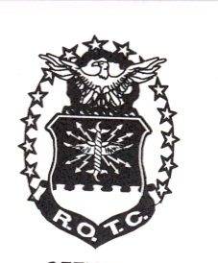

Go Back to Top

Figure 3.4. Female Headgear

Go Back to Top
Figure 3.5. Male Service Dress
Note: Cadets may wear the rank on both coat and shirt at the same time or only on the coat. The cadets must be in proper uniform at all times. If they have the coat on, the rank insignia must be on the coat. If they remove the coat, the rank must be on the shirt.

1. Awareness Presentation Team (APT) badge: Center on welt pocket 3 inches below the top.
2. Name tag: Center between arm seam and lapel with bottom edge parallel to top of welt pocket
3. Kitty Hawk Badge: see note 15.
4. Unit patch: Placed ½ to 1 inch below shoulder seam and centered.
5. Shoulder tabs: Center between unit patch and shoulder seam. If no patch, then 1 inch below shoulder seam.
6. Aerospace Education Foundation (AEF) Badge: see note 15.
7. Distinguished Cadet Badge: see note 15.
8. Grade insignia (officer or enlisted) worn on both lapels. Airman Basic wear lapel insignia on both lapels. Place insignia halfway up the seam, resting on but not over it. Bottom of insignia is horizontal with the ground.
9. AFJROTC Patch: Placed ½ to 1 inch below shoulder seam, and centered.
10. Flight Solo or Flight Certificate Badge: see note 15.
11. Ground School Badge: see note 15.
12. Ribbons: Center, on but not over edge of pocket. Wear 3 or 4 in a row. Wear all or some.
13. Academy of Model Aeronautic Wings: worn 1 inch below pocket.
14. Model Rocketry Badge: worn 2 inches below AMA Wings or 3 inches below pocket if no AMA Wings are worn.
15. First badge placed ½ inch above nametag or ribbons and is centered horizontally. Additional badges placed ½ inch above previous badge

Go Back to Top
Figure 3.6. Female Service Dress
Note: Cadets may wear the rank on both coat and shirt at the same time or only on the coat. The cadets must be in proper uniform at all times. If they have the coat on, the rank insignia must be on the coat. If they remove the coat, the rank must be on the shirt.

1. Name tag: authorized for wear and is to be centered on right side, even with to 1 1/2 inches higher or lower than the first exposed button.
2. Awareness Presentation Team Badge: see note 15.
3. Unit patch: center ½ to 1 inch below shoulder seam.
4. Shoulder tab: centered between unit patch and shoulder seam. If no patch, then 1 inch below shoulder seam.
5. Kitty Hawk Badge: see note 15.
6. Aerospace Education Foundation (AEF) Badge: see note 15.
7. Distinguished Cadet Badge: see note 15.
8. Grade insignia (officer or enlisted) worn on both lapels. Airman Basic wear lapel insignia on both lapels. Place insignia halfway up the seam, resting on but not over it. Bottom of insignia is horizontal with the ground.
9. Flight Solo or Flight Certificate Badge: see note 15.
10. Ground School Badge: see note 15.
11. AFJROTC Patch: center ½ to 1 inch below shoulder seam.
12. Academy of Model Aeronautic (AMA) Wings: see note 15.
13. Model Rocketry Badge: see note 15.
14. Ribbons: center ribbons resting on but not over edge of welt pocket. Wear 3 or 4 in a row. Wear all or some.
15. First badge placed ½ inch above name tag or ribbons (whichever is appropriate) and is centered horizontally. Additional badges placed ½ inch above previous badge.

Go Back to Top
Figure 3.7. Male Service Uniform
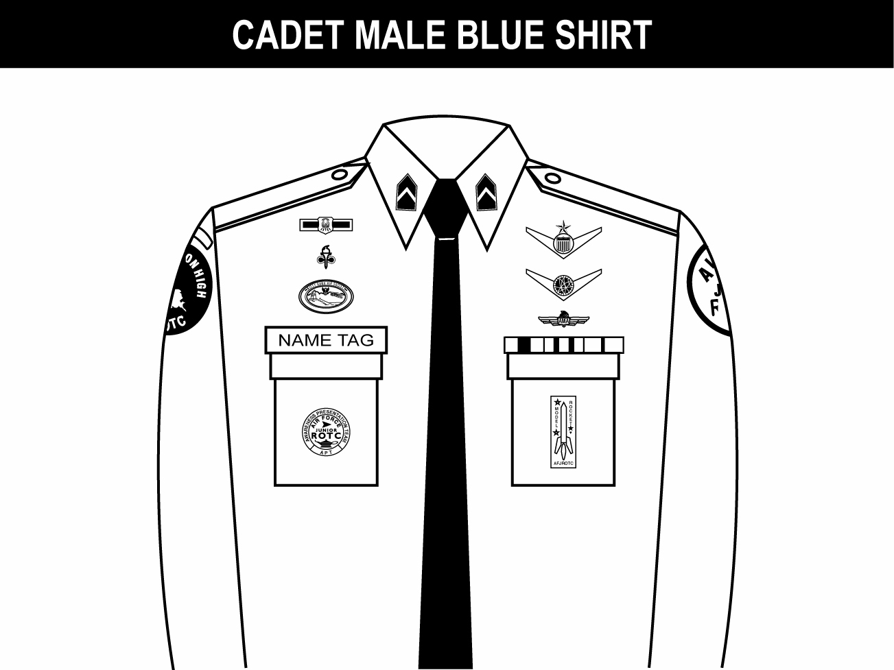

1. Awareness Presentation Team (APT) and Model Rocketry Badge are centered on the pockets on the appropriate sides as displayed above.
2. Name tag: authorized for wear and is to be grounded and centered over wearer’s right pocket.
3. Unit patch: center ½ to 1 inch below shoulder seam.
4. Shoulder tab: center between unit patch and shoulder seam. If no patch, then place 1 inch below shoulder seam.
5. Kitty Hawk Badge: see note 15.
6. Aerospace Education Foundation (AEF) Badge: see note 15.
7. Distinguished Cadet Badge: see note 15.
8. Grade insignia (officer or enlisted) worn on both left and right collar, centered side to side and top to bottom. For enlisted rank, the bottom point of torch points toward the point of the collar. Officer top point of rank aligned with point of collar. Airman Basic have no insignia of any kind on the collar.
9. (Officers only) When using officer cloth rank on epaulets versus miniature metal rank on collar, place as close as possible to shoulder seam.
10. Flight Solo or Flight Certificate Badge: see note 15.
11. Ground School Badge: see note 15.
12. Academy of Model Aeronautic (AMA) Wings: see note 15.
13. AFJROTC Patch: center ½ to 1 inch below shoulder seam.
14. Ribbons: ground and center on pocket.
15. First badge placed ½ inch above nametag or ribbons and is centered horizontally. Additional badges placed ½ inch above previous badge.
16. Wearing the blue tie is mandatory with the long sleeve blue shirt, optional with the short sleeve blue shirt.
Go Back to Top
Figure 3.8. Female Service Uniform
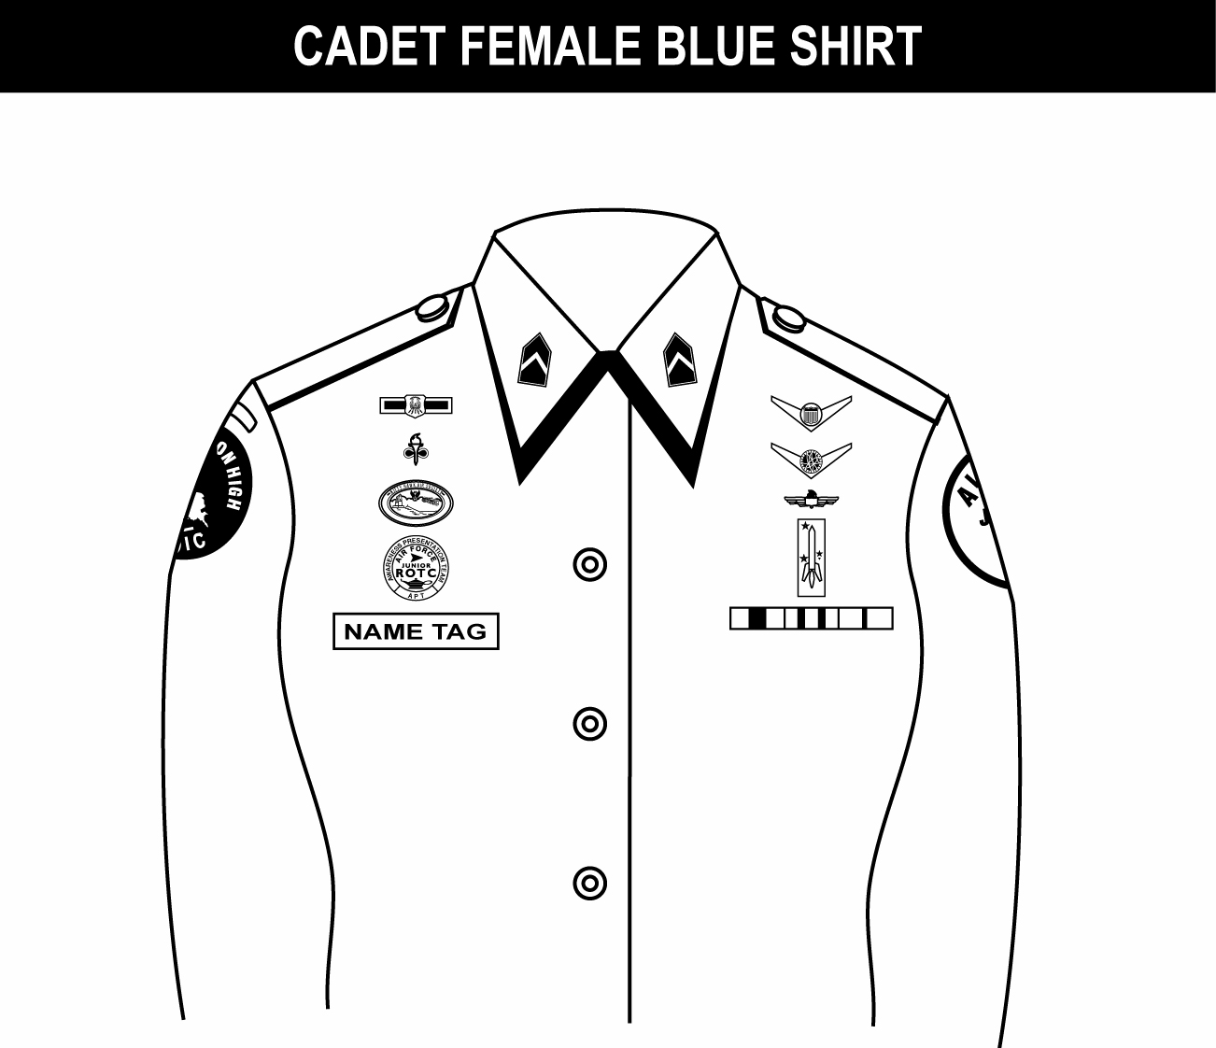
1. Name tag: authorized for wear and is to be centered on right side, even with to 1 1/2 inches higher or lower than the first exposed button.
2. Awareness Presentation Team Badge: see note 16.
3. Unit patch: center ½ to 1 inch below shoulder seam.
4. Shoulder tab: centered between unit patch and shoulder seam. If no patch, then 1 inch below shoulder seam.
5. Kitty Hawk Badge: see note 16.
6. Aerospace Education Foundation (AEF) Badge: see note 16.
7. Distinguished Cadet Badge: see note 16.
8. Grade insignia (officer or enlisted) worn on both left and right collar, centered side to side and top to bottom. For enlisted rank, bottom point of torch points toward the point of the collar. Officer top point of rank aligned with point of collar. Airman Basic have no insignia of any kind on the collar.
9. (Officers only) When using officer cloth rank on epaulets versus miniature metal rank on collar, place as close as possible to shoulder seam.
10. Flight Solo or Flight Certificate Badge: see note 16.
11. Ground School Badge: see note 16.
12. Academy of Model Aeronautic (AMA) Wings: see note 16.
13. AFJROTC Patch: center ½ to 1 inch below shoulder seam.
14. Model Rocketry Badge: see note 16.
15. Ribbons: Center, parallel with ground. Align with bottom of nametag. Or, if no nametag, align bottom of ribbons even with to 1 ½ inches higher or lower than the first exposed button.
16. First badge placed ½ inch above nametag or ribbons (whichever is appropriate) and is centered horizontally. Additional badges placed ½ inch above previous badge.
17. Wearing the blue tab is mandatory with the long sleeve blue shirt; it is optional with the short sleeve blue shirt
Go Back to Top
Figure 3.9. Lightweight Blue Jacket
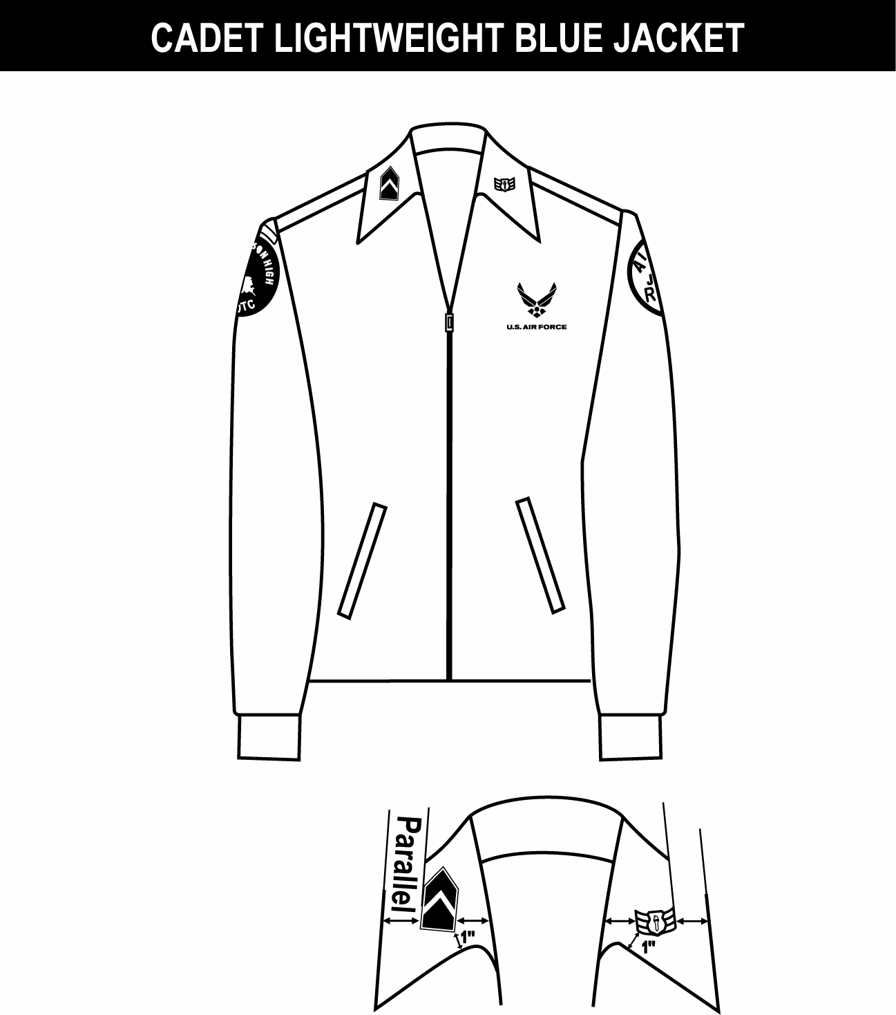

1. (Officers only) When placing rank on epaulet instead of collar, use standard size metal rank, center on epaulet 5/8 in from shoulder seam.
2. Shoulder tabs are centered between unit patch and shoulder seam. If no patch, then 1” below shoulder seam.
3. Unit patch on right sleeve ½ to 1 inch below shoulder seam and centered.
4. Grade insignia (officer and enlisted) is worn on both left and right collar. Airman Basic have no collar insignia.
5. Optional item: center vertically between the shoulder seam and where the underarm side seam joins the armhole sleeve and center horizontally between the center zipper and the sleeve armhole seam.
6. AFJROTC patch on left sleeve ½ to 1 inch below shoulder seam and centered.
7. Jacket will be closed to at least the halfway point.
8. Center insignia horizontally on collar. Place 1 inch from bottom of collar and parallel to the outer edge of the collar.

Go Back to Top
Figure 3.10. Battle Dress Uniform
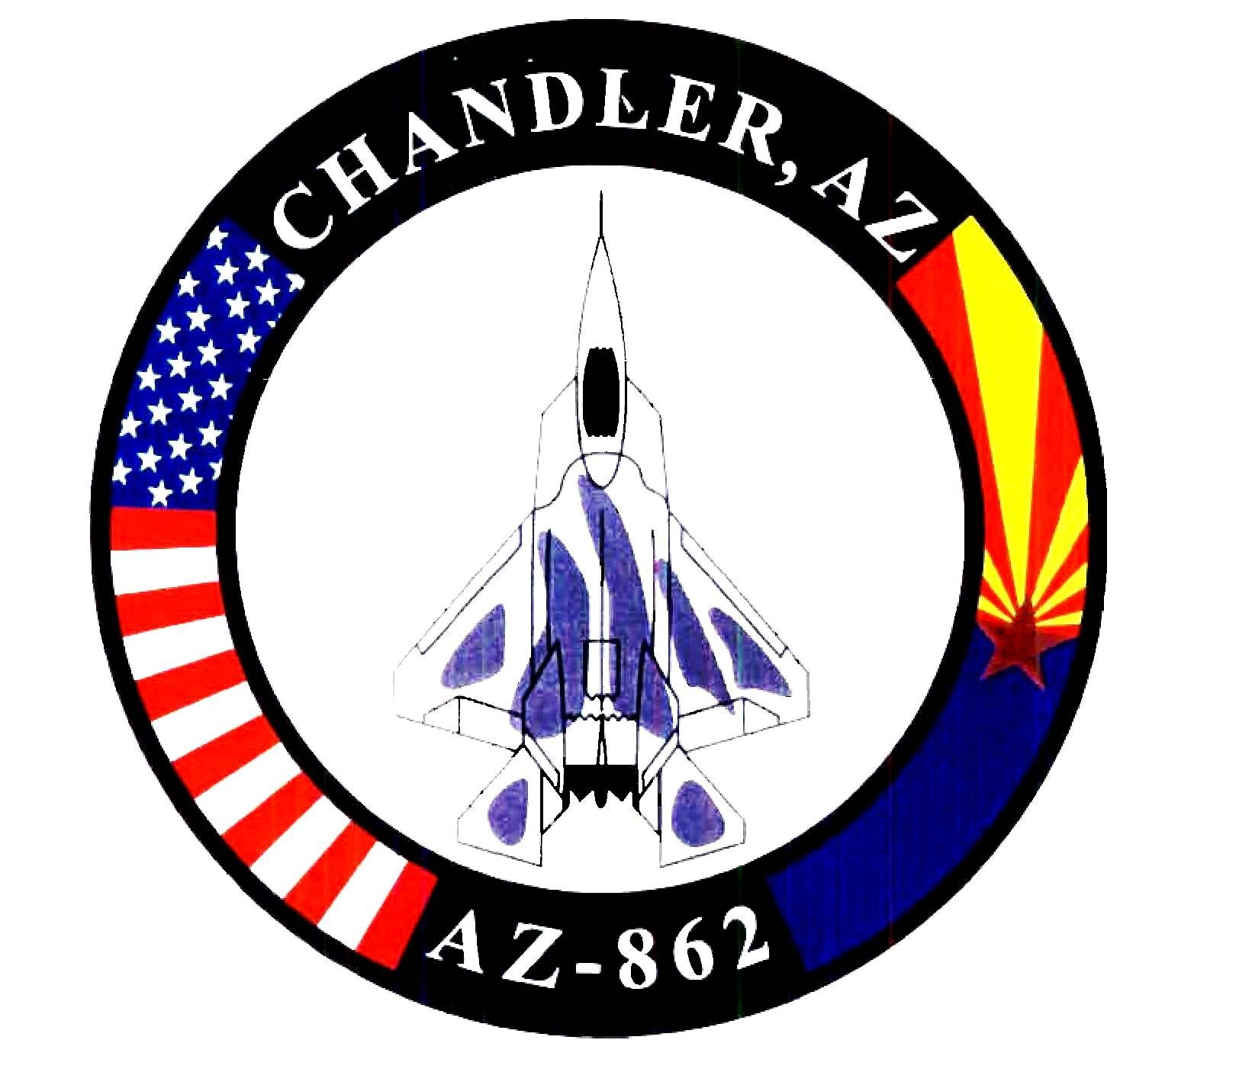
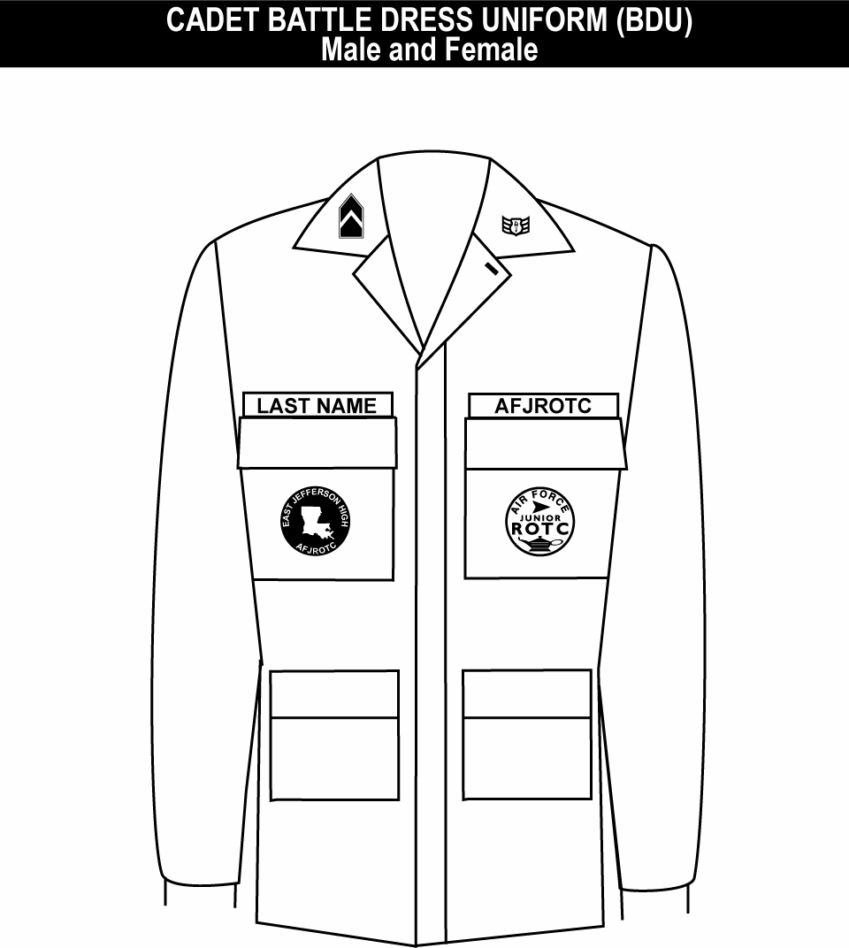

1. Unit patch worn on right pocket and centered.
2. Tapes grounded and centered on pockets.
3. Grade insignia (officer or enlisted) is worn on both left and right collars, centered on collar and parallel with bottom of collar. Airman Basic have no collar insignia.
4. AFJROTC patch worn on left pocket and centered.

Go Back to Top

Figure 3.11. How to tie a tie
How to tie the Windsor (Double Windsor) knot.
Wide and Triangular.
A full knot best suited for spread collar shirts.
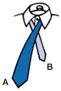 | 1. The wide end "A" should extend about 12 inches below narrow end "B". Cross wide end "A" over narrow end "B". |  | 2. Bring wide end "A" up through loop between collar and tie; then back down.
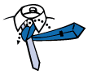 | 3. Pull wide end "A" underneath narrow end "B" and to the left, and back through the loop again. | 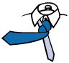 | 4. Bring wide end "A" across the front from left to right.
 | 5. Pull wide end "A" up through the loop again. |  | 6. Bring wide end "A" down through the knot in front.
 | 7. Using both hands, tighten the knot carefully and draw up to collar.

Go Back to Top

