Constitution and By-Laws
of the
Old Town Middle School National Junior Beta Club

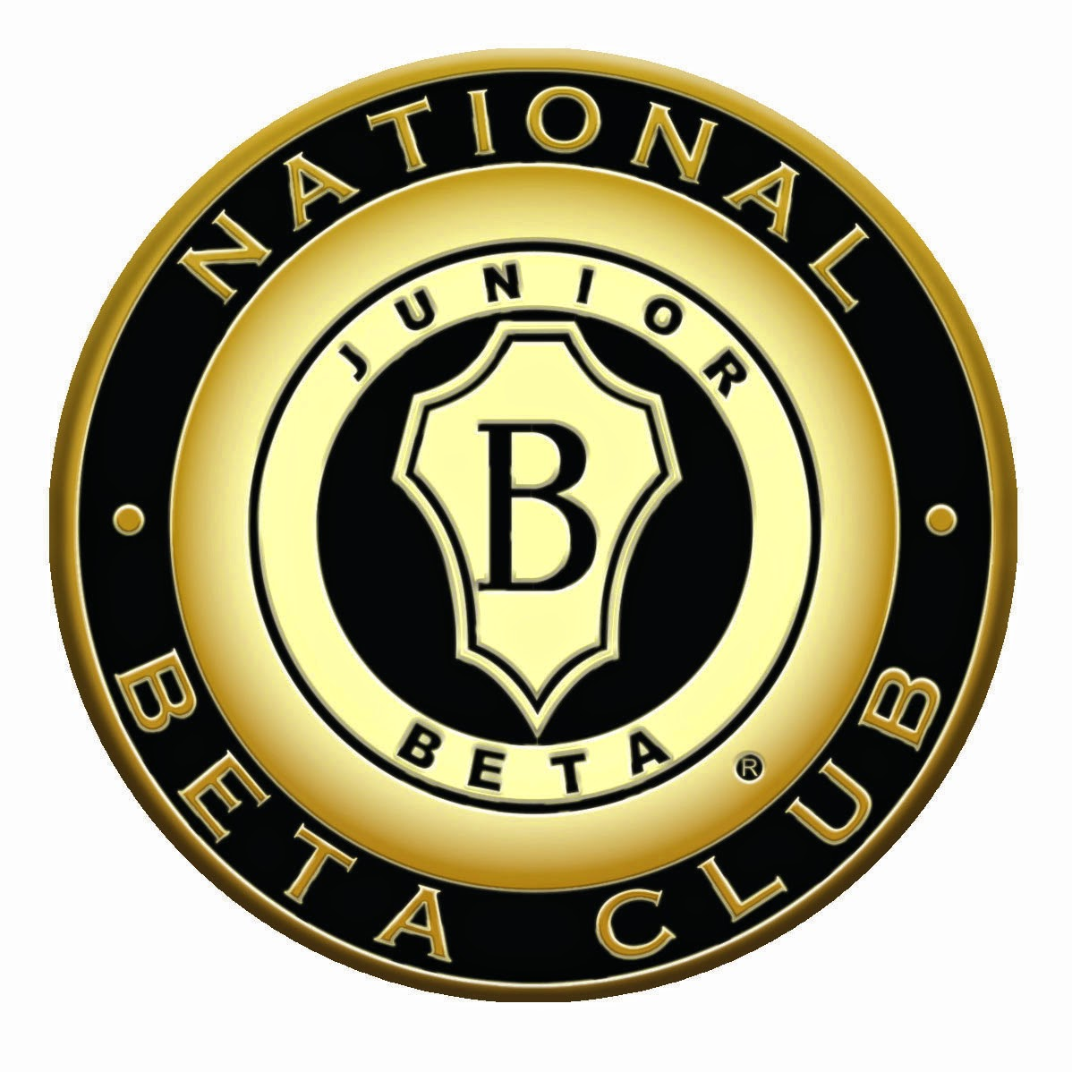

Article I
Name
The name of this organization shall be the Old Town Middle School Chapter of the National Junior Beta Club.
Article II
Time and Place of Meetings
The time and place of meetings of this chapter of the National Junior Beta Club shall be decided upon only after consultation with, and upon the approval of, the executive head of the Old Town Middle School.
Article III
Affiliation and Co-ordination
This chapter of the National Junior Beta Club is an integral part of the central organization of the National Junior Beta Club and shall be governed by the academic and financial policies laid down in the National Constitution of the central organization of the National Junior Beta Club. Its coat-of-arms, motto, colors, creed, and official insignia shall be those of the National organization of the National Junior Beta Club.
Article IV
Purpose
The purpose of this organization shall be the promotion of scholarship, leadership, and good citizenship at the Old Town Middle School.
Article V
Membership
The membership of this organization shall be made up from among the students with an 88 or above average in each subject of the Old Town Middle School who, because of their worthy character, good mentality, credible achievement, and commendable attitude, have been approved for membership by the executive head of Old Town Middle School; provided, of course, that these students meet the requirements as set in the By-Laws of this organization as appended herein below.

Article VI
Loss of Membership
A member of this chapter of the Beta Club may be dropped from membership if he is absent without justifiable reason from two regular meetings. New inductees will be dropped from membership without justifiable reason from one regular meeting. A justifiable reason must be presented with a note from member’s parent.
A member of this chapter of the National Junior Beta Club may be dropped from membership if his scholastic record falls below 88 in any subject.
However, no member may be dropped from membership for scholastic deficiency without being accorded a probationary period of one nine-week period to raise his scholastic record above the minimum required for membership.
A member of this chapter of the National Junior Beta Club will be placed on a probationary period if he/she receives a major disciplinary referral which will result in his/her membership being dropped if said member receives a second major disciplinary referral.
The executive head of Old Town Middle School may drop a member from membership for moral or disciplinary reasons that are deemed by her to be sufficient.
Service hours are a requirement. Each member will serve a minimum of two service hours per semester through time and donations.
A student so dropped from membership may be reinstated during the following open enrollment provided he/she meets the requirements laid down in the Constitution and By-Laws of this chapter of the National Junior Beta Club.
If a member is dropped from membership, a record of this action shall be relayed to the National Office of the National Junior Beta Club immediately.
Article VII
Service Project
This chapter of the National Junior Beta Club will undertake programs of service. These projects shall be decided upon only after consultation with and upon the approval of the executive head of the school.
Article VIII
Local Dues and Assessments
The local dues of this chapter of the National Junior Beta Club shall be $15.00 nonrefundable for induction. Dues must be paid to remain a member in good standing of the Old Town Middle School Beta Club.
Assessments may be made upon the membership to defray the costs of special undertakings.
Article IX
Amending the By-Laws
The By-Laws of this chapter of the National Junior Beta Club may be amended by a majority vote of the membership provided such proposed amendment is placed before the club at a previous meeting.
Article X
Amending the Consultation
The Constitution of this organization may be amended by a two-thirds vote of the membership at any meeting where a quorum is present if notice of the proposed amendment has been given at a previous meeting.
Article XI
Quorum
A quorum of this organization shall be constituted by majority of the membership. No action may be taken which is binding upon the membership unless a quorum is present. However, certain matters - such as, a discussion of means of taking in new members, the presentation if a program, etc. - may be carried on at a regular or special meetings without a quorum being present.
Article XII
Standards of Membership
Standards of membership in the Old Town Middle School chapter of the National Junior Beta Club must conform to the general features as laid down in the National Constitution; and in all cases must be approved by the executive head of the school.
The classes from which members may be drawn shall be sixth through eighth grades.
The scholastic requirements for membership in this chapter of the National Junior Beta Club shall be 88 or above average in each class.
Article XIII
Induction of Members
The induction of new members into the membership of this chapter of the National Junior Beta Club shall be one of the dignities appropriate to the ideals of the organization.
Article XIV
Officers
The officers of this chapter of the National Junior Beta Club shall be president, a vice-president, a secretary, and a treasurer.
The duties of the president shall be to preside at the meetings; to appoint the committees of the chapter (unless otherwise provided for in the by-laws); to represent this organization when necessary; and to administer the policies as laid down in this constitution and its by-laws. The president will be an 8th grader.
The duties of the vice-president shall be to preside at meetings when the president is absent or incapacitated to perform the duties of the office; and the duties of the second vice-president shall be to assist in administering the affairs of the chapter-serving on such committees as are designated in the by-laws and to oversee the monthly Beta program. The vice-president will be an 7th grader and will move into the position of president the following year.
The duties of the secretary shall be to keep a record of membership; to record the minutes of the meetings, and to carry on the necessary club correspondence.
_____________________________
Crystal Chase, Principal

_____________________________
Kelly Jackson, Sponsor

_____________________________
Blakeney McGraw, Sponsor

