Light Up My Relay
“ Light provides comfort in the darkness”

L

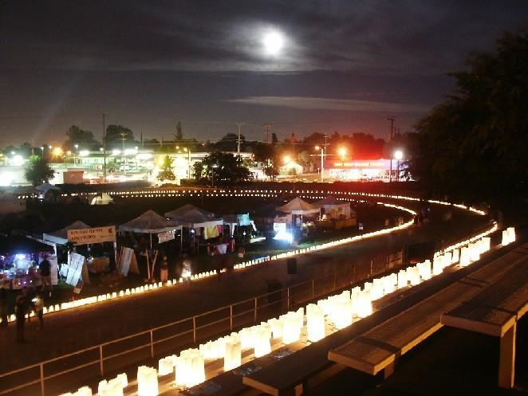
Those touched by cancer know the dark times this disease can bring. But even amid the darkness, lights of hope and comfort shine.
The American Cancer Society Relay for Life is an overnight event that unites community members against cancer. One of the cornerstones of this important event is the luminaria ceremony, where candles and light shine in honor of those who battle cancer and in memory of those who have been lost. As Relay for Life participants walk throughout the night, the Luminarias, Sky Lanterns and Tiki Torches of Hope can help provide light to their journey.
If someone in your life has been touched by cancer, order a Luminaria Bag, Sky Lantern or Tiki Torch of Hope in their honor or memory. Your donation will help fund the American Cancer Society’s fight against this disease, including research to help find a cure. To order “Light Up My Relay” inspirational items for your local Relay For Life, contact your American Cancer Society at
601-321-5500 or visit relayforlife.org

_____ Sky Lantern $25.00 donation

_____ White Luminaria Bag $10.00 donation

_____ Tiki Torch $100.00 donation

Relay For Life of: MADISON
May 2, 2013
Liberty Park
www.relayforlife.org



Be a part of this special ceremony to honor and remember those touched by cancer.
(Please print information)
Your name
Address:
City / State / Zip
Phone (Day / Evening)
Amount enclosed ___________________________________________
Add name of In Honor :______________________________
Add name In Memory of:_______________________________

Please make checks payable to: American Cancer Society
Please mail to: 1380 Livingston Lane Jackson, MS 39213

