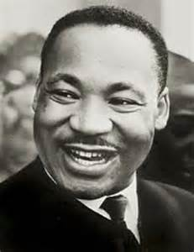\

**Brave**

**Hero**

**Dr. Martin Luther King, Jr.**

* **Born**: January 15, 1929, [Atlanta](https://search.yahoo.com/yhs/search;_ylt=A0LEVu9DsoVaRS4AxbsPxQt.;_ylu=X3oDMTEyNGozbWZ1BGNvbG8DYmYxBHBvcwMxBHZ0aWQDQjQxMjNfMQRzZWMDc2M-?p=Atlanta&type=cm&hspart=pty&hsimp=yhs-pty_maps&ei=UTF-8&fr=yhs-pty-pty_maps)
* **Died**: April 4, 1968, [Memphis, Tennessee](https://search.yahoo.com/yhs/search;_ylt=A0LEVu9DsoVaRS4AxrsPxQt.;_ylu=X3oDMTEyNGozbWZ1BGNvbG8DYmYxBHBvcwMxBHZ0aWQDQjQxMjNfMQRzZWMDc2M-?p=Memphis%2C+Tennessee&type=cm&hspart=pty&hsimp=yhs-pty_maps&ei=UTF-8&fr=yhs-pty-pty_maps)

**Parents**: [Alberta Williams King](https://search.yahoo.com/yhs/search;_ylt=A0LEVu9DsoVaRS4AyLsPxQt.;_ylu=X3oDMTEyNGozbWZ1BGNvbG8DYmYxBHBvcwMxBHZ0aWQDQjQxMjNfMQRzZWMDc2M-?p=Alberta+Williams+King&type=cm&hspart=pty&hsimp=yhs-pty_maps&ei=UTF-8&context=gsmcontext%3A%3Ayk_id%3A%3Ada2b222a-cb9c-4c22-8c2d-cc6f63430324&fr=yhs-pty-pty_maps), [Martin Luther King Sr.](https://search.yahoo.com/yhs/search;_ylt=A0LEVu9DsoVaRS4AybsPxQt.;_ylu=X3oDMTEyNGozbWZ1BGNvbG8DYmYxBHBvcwMxBHZ0aWQDQjQxMjNfMQRzZWMDc2M-?p=Martin+Luther+King+Sr.&type=cm&hspart=pty&hsimp=yhs-pty_maps&ei=UTF-8&context=gsmcontext%3A%3Ayk_id%3A%3Abaaaca29-0195-4459-aef8-1d914f4e15dc&fr=yhs-pty-pty_maps)

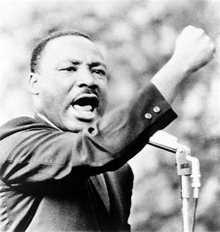

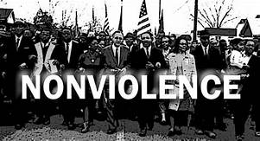

**Peaceful**

**Caring**

**Fun Facts**

1.MLK is the only non-president with a national holiday in his honor.

#### 2. In his efforts to fight segregation and inequality, King traveled more than six million miles and spoke more than 2,500 times.

3. King skipped ninth and 12th grades in high school and entered Morehouse College in Atlanta at age 15.

Dr. Martin Luther King, Jr. in one of the most influential leaders of the American Civil Rights Movement. He was a notable representative and leader in the movement from 1954 until he was assassinated. He lead peaceful protests using nonviolence to obtain equality for African American citizens. Dr. King never backed down in his stand against racism. His life was devoted to achieving equality and justice for all Americans of all colors.

Leader

Persistent